1. **BEAGLEBONE BLACK**

**Introduction**

Beagle Bone Black has been introduced as a low-cost developer platform supporting the ARM-A8 microprocessor development architecture. This mini-computer enables Linux to boot in under 10 seconds and boots on the Sitara AM335x ARM Cortex-A8 processor for developers in under 5 minutes with just a single USB cable.

In terms of specifications, this 8.6 x 5.3 cm motherboard is equipped with a 1GHz ARM Cortex-A8 processor (made by Texas Instruments) supporting graphics acceleration, a 46-pin connector for peripheral connections, 2GB of integrated flash memory and 512MB of DDR3 memory. The BeagleBone Black is also equipped with USB ports, Ethernet connections and HDMI supporting a resolution of 1280 x 1024 pixels.

BeagleBone Black uses a 5V DC power input that can be supplied from the USB port (USB cable included) or connected to adapters with the corresponding voltage level.

|  |  |
| --- | --- |
| Specification | Details |
| Processor | AM335x 1GHz ARM Cortex-A8 |
| RAM | 512MB DDR3 |
| Storage | 4GB eMMC on-board, microSD card support |
| Operating System | Debian Linux (default), supports custom OS |
| Connectivity | USB, Ethernet, HDMI, UART, SPI, I2C, GPIO |
| Power Consumption | 2.5W typical |
| I/O Pins | 2x46 headers (GPIO, PWM, ADC, SPI, etc.) |

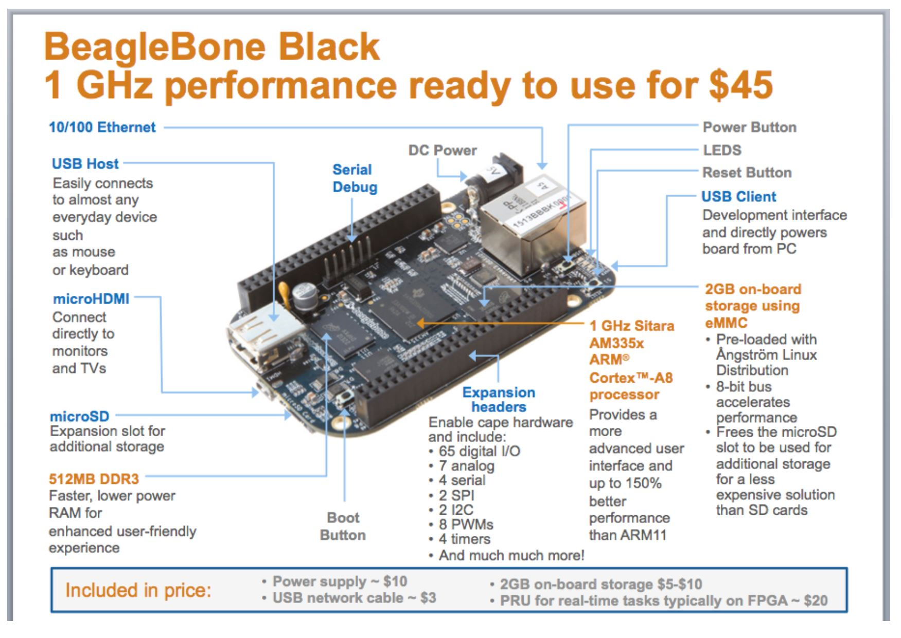

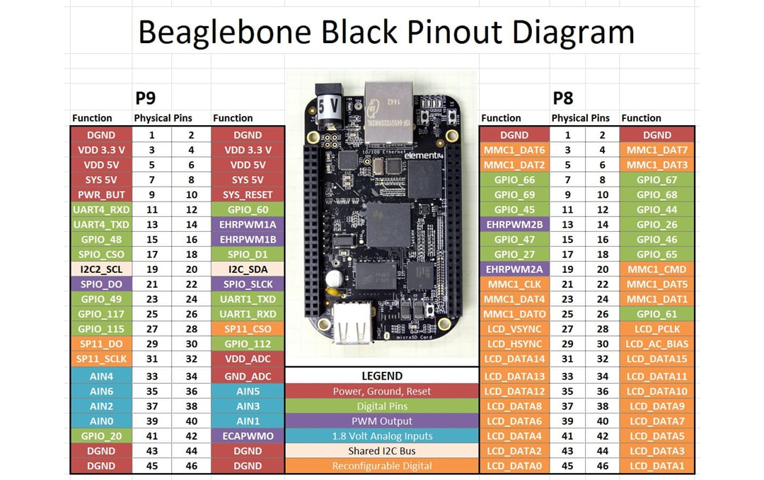

**PROS & CONS**

|  |  |
| --- | --- |
| Pros | Cons |
| High processing power | Not radiation-hardened (COTS component) |
| Supports full Linux OS | Higher power consumption |
| Multiple I/O interfaces | Complex for small subsystems |
| Excellent for payload processing or AI onboard | Requires shielding in space |

**COMMUNICATION**

The **BeagleBone Black** supports multiple communication interfaces essential for nanosatellite systems. It includes **UART (serial)** ports for GPS or telemetry modules, **I²C** and **SPI** buses for connecting to sensors and other peripherals, and **USB** (host and device modes) for data transfer or peripheral connections like flash drives. It also features a **10/100 Ethernet port** for high-speed networking and supports **CAN bus** for robust industrial communication. These interfaces are accessible through its **P8 and P9 header pins**, making the board highly versatile for various satellite subsystems.

**PROGRAMMING**

The BeagleBone Black (BBB) supports flexible and powerful programming options thanks to its built-in Linux operating system (usually Debian or Ubuntu). Users can write code directly on the board using high-level languages like Python, C, C++, JavaScript (Node.js), or even Shell scripting. It comes with Cloud9 IDE pre-installed, allowing users to code in a web-based environment through a browser by simply connecting the BBB via USB.

For hardware control, programmers can use libraries like Adafruit BBIO or libpruio to manage GPIO, PWM, UART, I²C, and SPI interfaces. It also supports the BoneScript library, similar to JavaScript, for easy control of hardware pins. Additionally, developers can write low-level code for PRUs (Programmable Real-time Units) to achieve real-time performance where needed. Programming is typically done via SSH access, remote desktop, or USB mass storage, making development highly accessible.

This versatility makes the BeagleBone Black an excellent platform for both real-time embedded control and high-level application development in nanosatellite systems

**Approximate cost**

1. Nerokas- ksh. 8000
2. Jumia- Ksh. 13,924

**3.) Applications of BeagleBone Black**

Used as an embedded computer in industry

* With low cost, easy to connect to peripheral devices, meeting industrial standards,
* Works well in temperature range from -40C to +85C, suitable for 3D printer or CNC projects

 Do Robot projects

RECOMMENDED USE:

* Payload data processing
* Image or signal analysis
* Backup On-Board Computer (OBC)

**Relevance of the Beagle Bone Black to a nanosatellite project**

The Beagle Bone Black is highly relevant to nanosatellite projects due to its powerful processing capabilities and rich I/O features. It is equipped with a 1GHz ARM Cortex-A8 processor and 512MB of RAM, making it suitable for data-intensive tasks like image processing, attitude control algorithms, and real-time data analysis. With onboard USB, Ethernet, HDMI, and GPIOs, it supports multiple sensor interfaces, external storage, and communication modules (e.g., GSM, GPS, RF). Its support for Linux (Ubuntu, Debian, etc.) allows for high-level programming, multitasking, and easier integration of open-source tools. The board's expandability via capes and its ability to run real-time applications using PRUs (Programmable Real-time Units) make it ideal for handling autonomous control systems within a satellite. Despite its relatively high power consumption, the Beagle Bone Black is perfect for ground simulation, payload control, or onboard data handling, where complex processing and flexibility are more important than ultra-low power operation.

**PIC16F877A MICROCONTROLLER**

**1. Features**

* Architecture: 8-bit RISC
* Clock Speed: Up to 20 MHz
* Program Memory: 14 KB Flash
* RAM: 368 Bytes
* EEPROM: 256 Bytes
* Operating Voltage: 2V – 5.5V
* I/O Pins: 33 (5 ports: A–E)
* Timers: 3 timers (Timer0, Timer1, Timer2)
* Watchdog Timer: Built-in for safety
* Interrupts: 15 total interrupt sources

**2. COMMUNICATION**

The PIC16F877A microcontroller supports essential communication protocols that are useful in nanosatellite subsystems. It features a USART (Universal Synchronous/Asynchronous Receiver/Transmitter) module for serial communication, often used with devices like GPS modules, RS-232 interfaces, and telemetry units. The serial transmit pin is RC6/TX (pin 25) and the receive pin is RC7/RX (pin 26). For high-speed sensor communication, it includes an SPI (Serial Peripheral Interface) that uses RC3/SCK (pin 18) for the clock signal, RC4/SDI (pin 23) for input data (MISO), and RC5/SDO (pin 24) for output data (MOSI). A separate digital I/O pin such as RA5 (pin 7) is commonly used as the Chip Select (CS) line for SPI. The I²C (Inter-Integrated Circuit) interface supports communication with multiple slower peripherals using just two lines: RC3/SCL (pin 18) for the clock and RC4/SDA (pin 23) for data. This is ideal for connecting to temperature sensors, EEPROMs, or real-time clocks. Additionally, the PIC16F877A includes a Parallel Slave Port (using PORTD: pins RD0 to RD7, pins 19–22 and 27–30) which enables 8-bit parallel data transfer, useful in applications requiring faster throughput or wide data buses. Unlike the PIC18F4550, the PIC16F877A doesnot have built-in USB or Ethernet, so such features would require external interface modules.

**3. PINOUT**

* 40-pin DIP (Dual Inline Package)
* 5 Ports:
  + PORTA (6-bit), PORTB–PORTD (8-bit), PORTE (3-bit)
* Pins support analog, digital, and interrupt-on-change

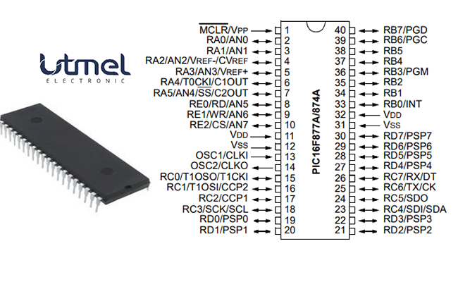

|  |  |  |  |  |
| --- | --- | --- | --- | --- |
| **Pin   Number** | **Pin Name** | | **Description** | |
| 1 | | MCLR/Vpp | | MCLR   is used during programming,     mostly connected to programmers like PicKit | |
| 2 | RA0/AN0 | | Analog pin 0 or 0 th   pin of PORTA | |
| 3 | RA1/AN1 | | Analog pin 1 or 1 st   pin of PORTA | |
| 4 | RA2/AN2/Vref- | | Analog pin 2 or 2 nd   pin of PORTA | |
| 5 | RA3/AN3/Vref+ | | Analog pin 3 or 3 rd   pin of PORTA | |
| 6 | RA4/T0CKI/C1out | | 4 th pin of PORTA | |
| 7 | RA5/AN4/SS/C2out | | Analog pin 4 or 5 th   pin of PORTA | |
| 8 | RE0/RD/AN5 | | Analog pin 5 or 0 th   pin of PORTE | |
| 9 | RE1/WR/AN6 | | Analog pin 6 or 1 st   pin of PORTE | |
| 10 | RE2/CS/AN7 | | 7 th pin of PORTE | |
| 11 | Vdd | | Positive supply for logic and /O pins | |
| 12 | Vss | | Ground reference for logic and VO pins | |
| 13 | OSC1/CLKI | | External Oscillator   /clock input pin | |
| 14 | OSC2/CLKO | | External Oscillator   /clock output pin | |
| 15 | RC0/T1OSO/T1CKI | | 0 th pin of PORT C | |
| 16 | RC1/T1OSI/CCP2 | | 1   st pin of POCTC     or Timer/PWM pin | |
| 17 | RC2/CCP1 | | 2   nd pin of POCTC     or Timer/PWM pin | |
| 18 | RC3/SCK/SCL | | 3 rd pin of POCTC | |
| 19 | RD0/PSP0 | | 0 th pin of POCTD | |
| 20 | RD1/PSPI | | 1 st pin of POCTD | |
| 21 | RD2/PSP2 | | 2 nd pin of POCTD | |
| 22 | RD3/PSP3 | | 3 rd pin of POCTD | |
| 23 | RC4/SDI/SDA | | 4   th pin of POCTC     or Serial Data in pin | |
| 24 | RC5/SDO | | 5   th pin of POCTC     or Serial Data Out pin | |
| 25 | RC6/Tx/CK | | 6   th pin of POCTC or     Transmitter pin of Microcontroller | |
| 26 | RC7/Rx/DT | | 7   th pin of POCTC     or Receiver pin of Microcontroller | |
| 27 | RD4/PSP4 | | 4 th pin of POCTD | |
| 28 | RD5/PSP5 | | 5 th pin of POCTD | |
| 29 | RD6/PSP6 | | 6 th pin of POCTD | |
| 30 | RD7/PSP7 | | 7 th pin of POCTD | |
| 31 | Vss | | Ground reference for logic and VO pins | |
| 32 | Vdd | | Positive supply for logic and /O pins | |
| 33 | RB0/INT | | 0   th pin of POCTB     or External Interrupt pin | |
| 34 | RB1 | | 1 st pin of POCTB | |
| 35 | RB2 | | 2 nd pin of POCTB | |
| 36 | RB3/PGM | | 3   rd pin of POCTB     or connected to programmer | |
| 37 | RB4 | | 4 th pin of POCTB | |
| 38 | RB5 | | 5 th pin of POCTB | |
| 39 | RB6/PGC | | 6   th pin of POCTB     or connected to programmer | |
| 40 | RB7/PGD | | 7   th pin of POCTB     or connected to programmer | |

**4. POWER**

* Operating Voltage: 2 – 5.5V
* Low power consumption
* Sleep Mode: For power saving
* Can run from battery or regulated DC supply

**5. PROGRAMMING**

* Languages: Assembly, Embedded C
* Programmer Required: e.g., PICkit 2 or 3
* Software:
  + MPLAB X IDE (Microchip)
  + MPLAB XC8 Compiler
* No operating system (bare-metal programming)

**6. OTHER FEATURES**

* ADC: 10-bit, 8 channels (for sensors)
* PWM: For controlling motors or servos
* Comparator Module: Analog signal comparison
* EEPROM: Non-volatile memory for saving data during power loss
* Timers with Prescalers: Good for real-time control

**7. Price**

* Approximate Cost: $3 – $6 USD (KES 400 – 800)

**8. Advantages**

* Cheap and readily available
* Easy to learn and use
* Great for real-time control applications
* Low power and space-efficient
* Excellent for simple I/O management and sensor interfacing

**9. Disadvantages**

* No USB or native Ethernet
* No OS support
* Low memory and processing power
* Not suitable for complex tasks like image processing or multitasking

## **PIC16F877 APPLICATIONS**

* Multiple DIY Projects
* Very good choice if you are learning PIC
* Projects requiring Multiple I/O interfaces and communications
* Replacement for Arduino Module
* Ideal for more advanced level A/D applications in automotive, industrial, appliances, and consumer applications.

**10. Relevance to Nanosatellite Project**

* **Ideal For**:
  + Sensor interfacing (temperature, magnetometer, gyroscope)
  + Real-time control of actuators (reaction wheels, antenna motors)
  + Power management tasks (battery switching, regulation)
  + Communication with higher-level controller (like BeagleBone)
* Excellent choice for subsystems needing low power and high reliability

**PIC18F4550 MICROCONTROLLER**

**1. Features**

* Architecture: 8-bit RISC
* Clock Speed: Up to 48 MHz
* Program Memory: 32 KB Flash
* RAM: 2 KB SRAM
* EEPROM: 256 Bytes
* Operating Voltage: 2.0V – 5.5V
* I/O Pins: 35 (on 40-pin DIP)
* Timers: 4 timers (Timer0–Timer3)
* Watchdog Timer: Present
* Oscillator Options: Internal and external oscillator support

**2. COMMUNICATION**

The PIC18F4550 microcontroller supports multiple communication protocols essential for nanosatellite systems. A standout feature is its USB 2.0 interface (Full-Speed at 12 Mbps), enabling device or host modes via RC4 (pin 23, USB D–) and RC5 (pin 24, USB D+). This allows direct PC connection for programming or data transfer to USB peripherals—useful in ground testing and diagnostics.

For serial communication, it offers a USART module using RC6/TX (pin 25) and RC7/RX (pin 26), ideal for connecting GPS, GSM, or telemetry modules. It also includes a high-speed SPI interface with RC3/SCK (pin 18), RC4/SDI (pin 23, MISO), and RC5/SDO (pin 24, MOSI), plus a user-defined Chip Select (e.g., RA5/pin 7)—commonly used for sensors, flash memory, or SD cards.

For low-speed peripherals, the I²C bus uses RC3/SCL (pin 18) and RC4/SDA (pin 23), enabling multiple device communication over just two lines, ideal for EEPROMs, gyroscopes, or RTCs. While it lacks built-in Ethernet, its USB support compensates well. Altogether, these communication options make the PIC18F4550 highly adaptable for modular nanosatellite subsystems.

**3. PINOUT**

* 40-pin Dual Inline Package (DIP) or 44-pin QFN/TQFP
* PORTA–PORTE:
  + Configurable as analog or digital I/O
  + USB uses specific pins (D+ and D− on RC4 and RC5)
* Each pin can source/sink 25 mA (good for LEDs/small loads)

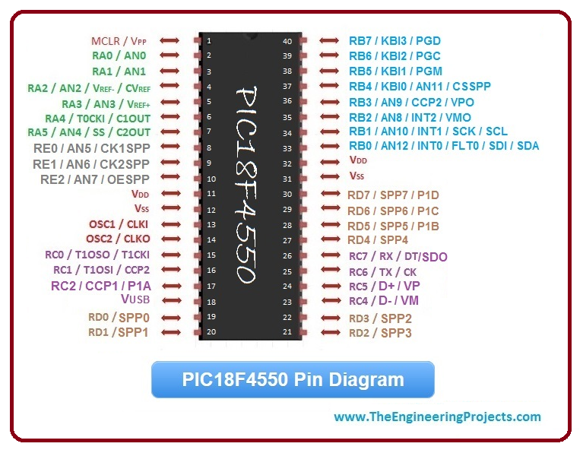

**4. POWER**

The PIC18F4550 operates within a voltage range of 2.0V to 5.5V, making it flexible for various power sources, including direct USB-powered operation at 5V. It features power-saving modes such as Sleep, which shuts down most internal functions to conserve energy, and Idle, useful for USB suspend mode during low activity. These modes help reduce power consumption, which is critical for energy-limited systems like nanosatellites, ensuring longer operational life and thermal efficiency in space environments.

**5. PROGRAMMING**

* Languages: Assembly, Embedded C
* Tools:
  + MPLAB X IDE
  + XC8 Compiler
  + USB bootloader (no external programmer needed) or PICkit 2/3
* Supports In-Circuit Serial Programming (ICSP)

**6. OTHER FEATURES**

* 10-bit ADC (13 channels)
* PWM outputs
* USB support (Device/Host mode)
* Enhanced PWM (ECCP) Module
* Comparator & Voltage Reference Modules
* Enhanced Flash endurance – 100k erase/write cycles

**7. PRICE**

* Approximate Cost: $4 – $8 USD (KES 500 – 1000)

**8. ADVANTAGES**

* USB support for data transfer and programming
* Large Flash and RAM compared to PIC16 series
* Suitable for medium-complexity tasks
* Built-in ADCs for sensors
* Multiple communication protocols
* Can act as a USB device or host

**9. DISADVANTAGES**

* Still 8-bit, so limited processing power
* Not ideal for multitasking or heavy data processing
* No built-in Ethernet or wireless communication
* Higher power than ultra-low-power MCUs

**10. RELEVANCE TO NANOSATELLITE PROJECT**

* **Ideal For**:
  + USB interfacing with ground station or data loggers
  + Command and data handling subsystems
  + Interfacing sensors (thermal, magnetic, etc.)
  + Mid-level task control
  + Communication with Beagle Bone (via serial or USB)
* Better than PIC16F877A for subsystems requiring USB, more memory, and faster response

**CONCLUSION**

BeagleBone Black, PIC16F877A, and PIC18F4550—each offer unique advantages that are valuable to nanosatellite systems. The BeagleBone Black provides powerful processing and Linux-based flexibility, making it suitable for tasks that require complex computation, such as payload data handling or onboard processing. The PIC18F4550, with its USB support and multiple communication protocols (USART, SPI, I²C), is ideal for peripheral interfacing and efficient data transfer. Meanwhile, the PIC16F877A, known for its simplicity, low power consumption, and robust peripheral features, fits well in control and monitoring tasks. Collectively, these microcontrollers demonstrate how different hardware platforms can be strategically used to address various functional needs in a nanosatellite, from real-time control to communication and data processing.